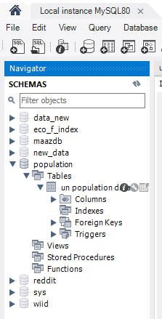 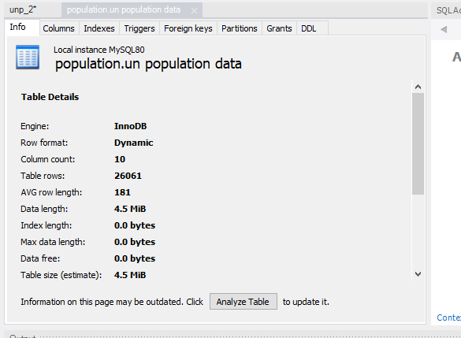

The amount of data that is rendered to a database depends on the size of the dataset and the capacity of the database to store and retrieve data.